Reel1.0 Quick Guide

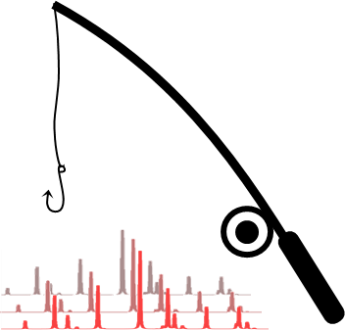By Frederik Holm Gjørup   
June 2021

Contents

Welcome 2

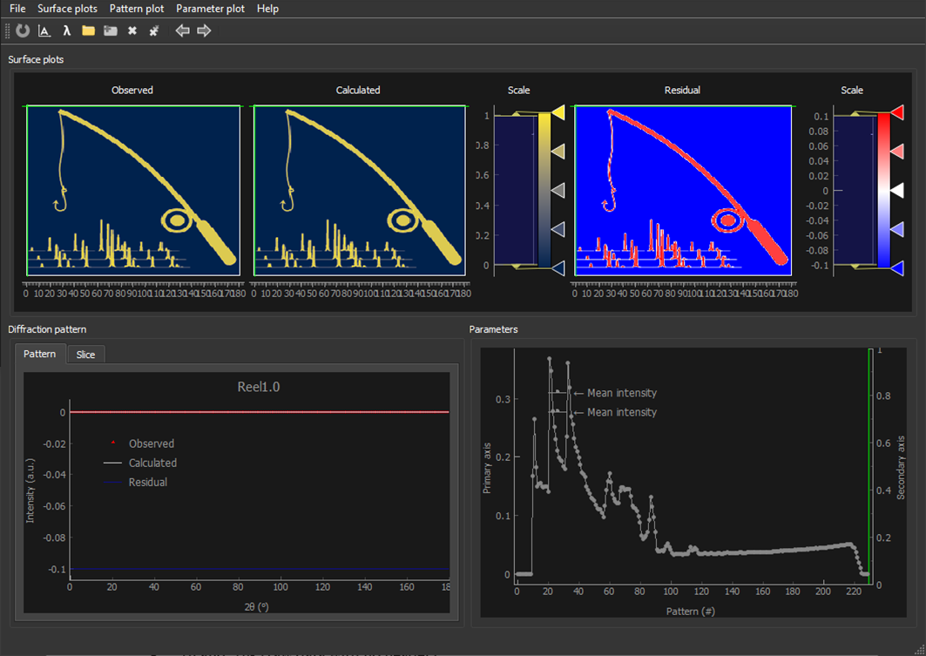Installation (Windows) 2

Pinning the shortcut to start/toolbar 2

Installation (MAC) 2

Getting started 3

Data formats 4

Custom *.xyy* file format for Reel1.0 4

# Welcome

Reel1.0 is a visualization tool for diffraction data and refinement results, intended for *in-situ, operando,* or similar larges datasets. The program allows the user to “Reel” through their data and quickly asses the quality of a multitude of refinements. While the idea for the program came from parametric refinements, it is equally applicable for sequential refinements or even raw data. Reel1.0 is written in Python and is open-source and free for all to use, however, I kindly request that it is not distributed with commercial intend. I hope that you enjoy the program and encourage any and all feedback.

-Frederik

# Installation (Windows)

Reel1.0 comes as a collection of python files, and as such, require the user to install Python 3 and a few non-built-in modules. All the modules can be installed using *pip install* or *anaconda*. The latest version-requirements are: (May 2021)

Python 3.8.3

Non-built-in python modules:

|  |  |  |
| --- | --- | --- |
| **Module** | **Version** | **pip install command** |
| PyQt5 | v. 5.14.2 | pip install PyQt5 |
| pyqtgraph | v. 0.11.1 | pip install pyqtgraph |
| matplotlib | v. 3.3.3 | pip install matplotlib |
| numpy | v. 1.19.5 | pip install numpy |
| scipy | v. 1.6.0 | pip install scipy |

+ Requirements imposed by the modules. Use *pip show [module]* for information about your current version.

Once all the required modules are installed, run the *setup.bat*. This will make the *run_Reel.bat* file and a *Reel1.0* shortcut. Open the program by double-clicking the short-cut or the *run_Reel.bat* file.

If the program does not open, check that the path to *python.exe* in *run_Reel.bat* line 5 is valid.

## Pinning the shortcut to start/toolbar

In order to pin the shortcut to the windows toolbar or start menu, right-click the *Reel1.0* shortcut, go to *properties*, add *C:\Windows\explorer.exe* in front of the *target* path, and click *OK*. Right-clicking the shortcut will now allow you to pin the shortcut to the start menu and the toolbar.

# Installation (MAC)

There are no shortcut or batch files for mac-users, instead, open a terminal window, navigate to the *Reel1.0* folder, and run the *Refinement_evaluator_ver1.0.py* in python.

# Getting started

New files are opened by clicking the *Open* button and selecting the desired file format in the dialog box.[1] Open several datasets by clicking the *Add dataset* button, and change between the opened datasets by clicking their names, the *Next* or *Previous* buttons, or with (ctrl+arrow keys). Update the current dataset by clicking *Update* or the hotkey (F5). Remove one or all dataset(s) by clicking the *Remove* buttons.

"Reel" through frames by dragging the green *Reel cursor* lines, either in the *Surface* plots or in the *Parameter* plot, or by using the arrow keys.

Select which parameters to plot and which axis to plot them on in the *Parameter plot* menu. Likewise, choose available sub plots from the *Pattern plot* menu.

You can scale the intensities separately for the *surface* plots and the *pattern* plots in the *Surface plot* and *Pattern plot* menus. Notice that scaling one will not affect the other. Adjust the colormap scaling by moving the yellow upper and lower boundaries in the *scale bar histograms* in the *surface* plot.

There are several options for zooming and panning in the plots. Change between the zoom modes for a given plot by right-clicking in the plot and selectin *Mouse Mode*. Auto-scale the range for all plots by clicking *auto-range* or using the hotkeys (A) or (space).

You can manually set the wavelength by clicking the *Set wavelength* button.

You can change the user defined default settings by editing the *ReelUserSettings.py* file, and restore the default settings from the *Help* menu in *Reel1.0*.

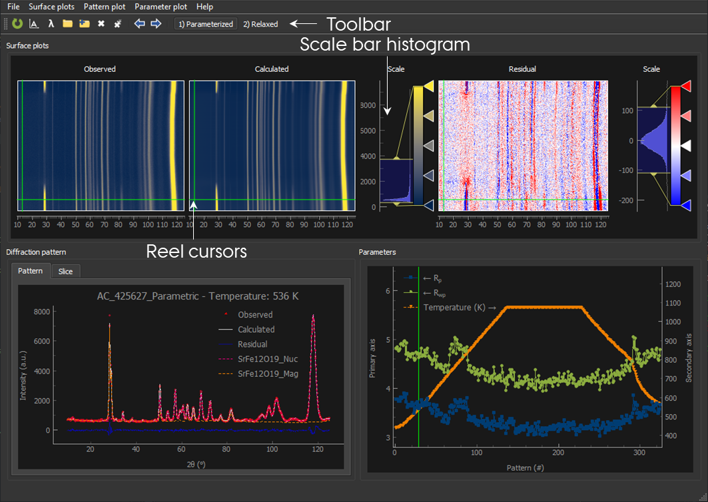

# Data formats

Reel accepts several common data formats, but for the full range of option, use the *.xyy* format, as described below. The accepted data formats are:

* *.xyy* (custom Reel1.0 format)
* *.prf* (FullProf, prf=3)[2]
* *.prf* (JANA)[3]
* *.dat* (FullProf, ins=0, 10)[4]
* *.xy* and *.xye* (raw data with no header)
* *.csv* (2θ in the first line and intensities in consecutive lines)

## Custom *.xyy* file format for Reel1.0

The following is a guide to the custom *.xyy* file format intended for *Reel1.0*.

The header is separated in several parts. It starts with a *mandatory* filename on the first line. Then follows a section of *keywords* ending on a colon and followed by a *value*. There are three keywords of special significance: *R_wp:, Temperature (K):,* and *Wavelength (Å):*. Any additional colon-separated *keywords* and *values* are read by the program and can be plotted in the *parameter plot*.

The *keyword* section is terminated by the beginning of the comments section. The comment section is started with *COMMENTS*, and any additional lineswill be ignored by the program, until the *END OF HEADER* line*.*

The data columns start with a column label, followed by the data. *Reel* expects the following *mandatory* columns: "*tth” and “Y_obs”* (case sensitive), and three optional columns with special meaning:*“Y_calc”, “Y_res”, and “Background*”. Any additional columns will be added as *sub plots* with their corresponding label, separated by *space*.

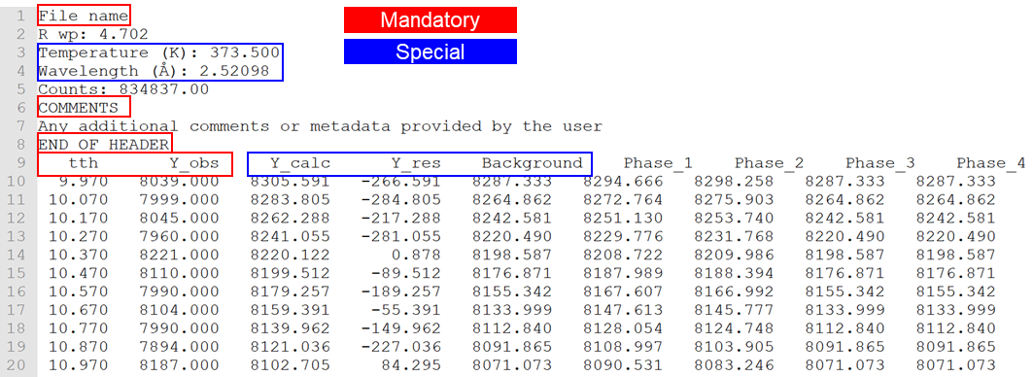

1. **NB:** The file order might depend on the sorting order of the current folder!
2. FullProf manual p. 73
3. JANA2006 cookbook p. 773
4. FullProf manual p. 74